
Submit completed Application to the Submission Portal: https://friaa.ab.ca/program-submissions/
Forest Resource Improvement
Association of Alberta
P.O. Box 11094, Main Post Office,
Edmonton, Alberta T5J 3K4
FOREST RESOURCE IMPROVEMENT PROGRAM (FRIP)
Proposal Application Template
Applicant Information
Applicant Name: |  |  | Brendan Casey |  |  |  |  |  |  |  | Phone: | 780-920-1787
Project Contact: |  |  | Brendan Casey |  |  |  |  |  |  |  | Email: | bgcasey@ualberta.ca
Mailing Address: |  |  | 1-099 Centennial Centre for Interdisciplinary Science (CCIS)  11335 Saskatchewan Dr NW, Edmonton, AB T6G 2M9 Edmonton AB  T6G 2H5
Project Title: |  |  | Predicting bird diversity along a mixedwood gradiant
Project Type: |  |  | Applied Research |  | Project Sub-Type: |  |  |  | Wildlife
Term of Project: |  |  | 01/01/2024 to 31/12/2025
Amount of Funding Applied for: |  |  | 54000 |  |  |  | Project Sponsorship from another Company? |  |  | Click to select option
Supporting Document Checklist (check all applicable): |  | ☐  ☐ |  | Project Sponsorship Form(s) appended? (only required for projects with sponsorship)  Other (describe): Click or tap here to enter text.
Acknowledged by Applicant
The Applicant acknowledges having read and agrees to the terms and conditions described on the template FRIP Project Grant Agreement (27-Jun-2016) to which this Application under FRIP (the “Program”) is made subject. The Applicant acknowledges and agrees that by its submission of this Application it shall be bound by the terms of the Program, these terms and conditions, and FRIAA’s policies, procedures, protocols and guidelines. The Applicant also acknowledges and agrees that this Application may be accepted by FRIAA on further terms or conditions, which shall be binding on the Applicant once the proposed project is undertaken by the Applicant.

 12/12/2023
 | Applicant Signature |  |  |  |  |  |  | Date

PROJECT DESCRIPTION
Provide a general overview of the project, application of results and describe the project type as identified on Page 1.

PROJECT BACKGROUND
Describe any background information relevant to the development of this proposed project. Describe prior project phases, other FRIP-funded or company-funded projects that relate to this project. This section is intended to introduce the context of the proposed project. For research projects, describe relevant references.

Industrial forestry in North America has led to simplified even-aged conifer dominated forests (Venier et al. 2014, Brandt et al. 2013). In response, there is growing interest in promoting mixed conifer-broadleaf stands that balance timber production with environmental goals (Franklin and Johnson 2012, Huberman and Eskelson 2023). Comparative studies between mixed-wood and conifer-dominated stands suggest that mixedwoods support higher levels of biodiversity, provide more habitat for cavity-nesting species, and have greater forest productivity (Hobson and Bayne 2000, Cumming et al. 2014, Felton et al. 2021, Huberman and Eskelson 2023). While many studies have compared coniferous monocultures to mixedwood stands, few have examined mixedwoods along a coniferous-deciduous gradient or sought to identify deciduous thresholds that maximize biodiversity.

PROJECT OBJECTIVES
Provide a general overview of the project. Describe the objectives of the project. These objectives should outline how your project specifically relates to the purpose of FRIP, which is to:
- Enhance the forest resources of Alberta;
- Serve the interest of all Albertans;
- Support activities that are above and beyond required forest management functions.
The project objectives must not absolve members or government of their respective responsibilities for sustained yield forest management. For research projects, describe research objectives.

To assess the influence of varying degrees of mixedwood on breeding bird communities, we will (1) examine how bird species diversity and composition varies across a coniferous-deciduous gradient, (2) identify scale-dependent effects of mixedwood composition on bird communities, and (3) use, evaluate, and compare discrete measures of mixedwood composition from forest inventories, and continuous, pixel-based measures derived from satellite remote sensing.

PROJECT DELIVERABLES
Describe the project deliverables and how they will be made available to FRIAA, stakeholders and to the public. Any anticipated project outcomes can also be illustrated in this section. Examples of Project Deliverables may include number of hectares treated/assessed, number of education events, number of new plans, number of surveys, or other appropriate metrics.

This project will include the following deliverables:
- Progress Report: Upon the conclusion of phase 1, an interim report will be submitted, outlining the progress made to date and presenting initial findings.
- Peer-Reviewed Manuscript: A paper will be published in a high-impact ecology or remote sensing journal.
- Predictive Maps: All spatial predictions and model results will be made available through Google Earth Engine applications.
- Final Report: A comprehensive report will be provided, detailing model results, project deliverables, the impact of the project, and recommendations for future research.

FOREST RESOURCE IMPROVEMENT
Describe which forest resource or what aspect of forest resource management the project will help to improve and how.

COMPANY RESPONSIBILITY
Describe how the proposed work is over and above company responsibilities.

Note: Applicants must demonstrate that no FRIAA funding will be applied to activities or aspects of the proposed project that is the company’s responsibilities under legislation, regulations, tenure, policy or general practice.

PROJECT WORKPLAN AND METHODOLOGY
Describe the project workplan and/or methodology to be used. This should include a description of the eligible activities proposed (see Program Description for eligible activities). Adequate detail must be provided so it is clear what activities are taking place and how they will be carried out. For research projects, describe the research methods, design and outline what has been done by the company to date in the way of a scientific review or independent peer review to assess sound experimental design and methodology.

We will use point count and acoustic monitoring data from the Boreal Avian Modelling Project’s avian dataset and www.wildtrax.ca, collected between 1995 and 2023. Site-level bird species richness and Shannon diversity will be computed for each point count location.
This will be a multi-phase project. In the initial phase we will use discrete, polygon based measures of mixedwood composition derived from vegetation inventories. Subsequent phases will involve the use of higher-resolution, multi-temporal landcover data obtained through remote sensing (e.g. Hermosilla et al. (2022)). Throughout both phases, analyses will incorporate mixed-effects regression models to assess how the proportion of deciduous cover influences the taxonomic diversity of birds across multiple scales (100-5000 m radii). The methodological workflow is illustrated in Figure 1.
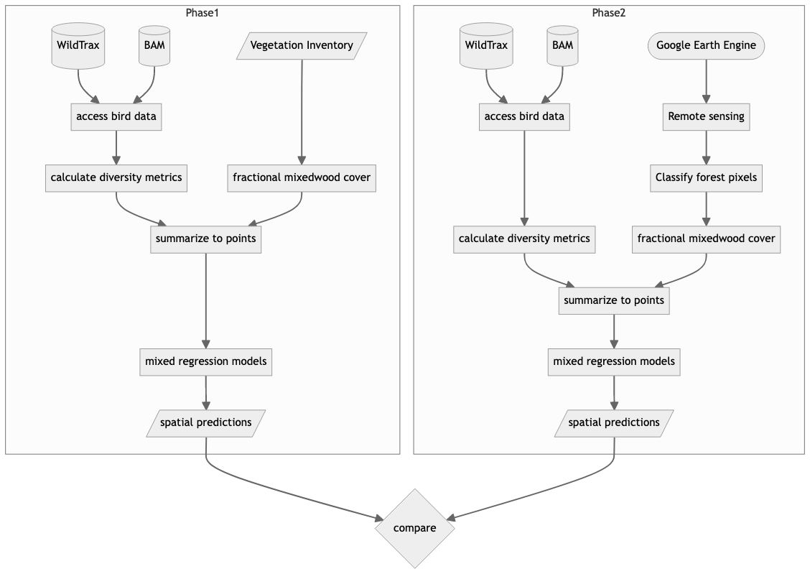
Figure 1: Diagram of the project’s methodological workflow.

PROJECT AREA
If applicable, describe the project area, site selection and any communities involved in the proposed project. Ensure the map with legend and reference points are clear and legible.

We will concentrate on the mixed conifer–hardwood forests of Alberta and British Columbia. Deciduous trees in the region include trembling aspen (Populus tremuloides), balsam poplar (Populus balsamifera), and birch (Betula spp.) Coniferous trees include black spruce (Picea mariana), white spruce (Picea glauca), jack pine (Pinus banksiana), and lodgepole pine (Pinus contorta) (Demarchi 1996, Natural Regions Committee 2006).
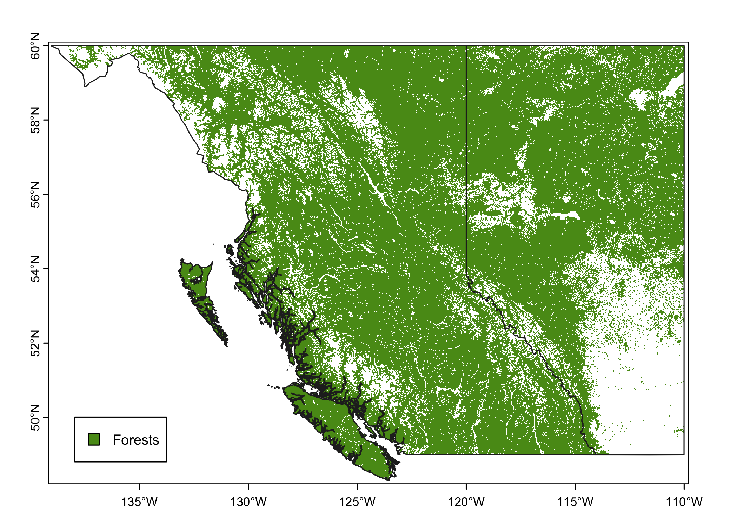

PROJECT MANAGEMENT
Describe the project management measurements in place to ensure the project is completed on time and within budget. Identify the project manager and any other key individuals. Provide their contact information and a description of their qualifications and/or experience.

To ensure the successful and timely completion of our project, to track progress, manage resources, and stay within the allocated budget, we will implement the following:
- A detailed project timeline with specific milestones and deadlines (see Appendix)
- Regular progress reviews conducted to ensure adherence to the schedule.
- Completed milestones will be measured against the planned timeline.
- Communication channels including advisory team meetings and status reports.

Project Manager: Brendan Casey, bgcasey@ualberta.ca.
Brendan will take the lead on the project, manage the proposed timeline, conduct all of the project analyses, and write and submit progress reports.

Project Supervisor: Erin Bayne, bayne@ualberta.ca.
Erin Bayne will supervise Brendan Casey, ensure compliance with the proposed timeline, and review all deliverables.

STAKEHOLDER REVIEW
Describe any adverse impacts on other forest resources or users and (if applicable) describe the feedback from impacted stakeholders.

PERMITS/LICENSES REQUIRED
Include or describe permits, licences or authorizations that are required to undertake the proposed work. If these are in-progress, describe the approval status of these documents or the process that the applicant will undertake to obtain approval prior to commencement of the project. Provincial Crown land may require a TFA and ACO approval.

N/A

BUDGET, REPORTING AND PAYMENT SCHEDULES

DESCRIBE PROJECT BUDGET AND FUNDING REQUEST
Describe the detailed project budget and the funding requested from FRIAA. Proposed costs for activities must contain sufficient detail (e.g. unit costs and estimated number of units) to allow for assessment of transparency, competitiveness and consistency with fair-market value. If project includes a request for a project administration fee, describe what this administration fee covers in this section. Details to be provided in Section 3.2

DETAILED PROJECT BUDGET
**The below table must be completed using the information in your Proposal. Adjust Description and Units of tasks to your specific project. Not all tasks outlined below will be relevant to your proposed project.**

Activity Type | Description | Unit Quantity | Unit Type | Unit Price | Total
Project Expenses
 | Project Personnel #1 (Brendan Casey) | 2 | year | $ 15000 | $ 30000
 | Remote sensing data (Planet) | 2 | year | $ 12000 | $ 24000
Total Project Budget |  |  |  |  | $ 54000
In-kind Services | *Not to be included in total project budget
 | Project Manager #2 (Name) | x.x | hour | $ x.x | $ x.x
 | Project Personnel #1 (Name) | x.x | hour | $ x.x | $ x.x
 | Project Personnel #2 (Name) | x.x | hour | $ x.x | $ x.x
 | Vehicle | x.x | kms | $ x.x | $ x.x
 | Quality Control and Assurance | x.x | hour | $ x.x | $ x.x
Sub-total |  |  |  |  | $ x.x

PROGRESS REPORTING AND PAYMENT SCHEDULE
Link your proposed progress reporting schedule to the payment schedule and completion of project milestones/deliverables. Progress Reporting should be determined based on the project timelines, deliverables and funding requests. For example, Progress Report #1 may be produced shortly after the project approval, Progress Report #2 may occur at partial project completion (50% completion) and final reporting at the project completion (Final Outcomes Report). Multi-year projects may produce annual reports, which can be tied to payments. You may require additional progress reporting intervals depending the length, scope and specifics of your proposed project. A minimum of 20% of the approved funding shall be released upon the submission of a Final Outcomes Report, if requesting otherwise, outline reasoning in this section. The submission of a financial report and supporting documentation is required to receive a grant payment. Use the table below to outline milestones and deliverables that will be provided to FRIAA.

Milestone/  Progress Report | Milestone/Description | Reporting Period |  | FRIAA Payment
 |  | Start Date | End Date
1 | AVI Based Models | 2024-01-01 | 2024-03-31 | $ funds to be released
2 | Submit progress report |  | 2024-03-31 | $ funds to be released
3 | Remote sensing based models | 2024-04-01 | 2025-06-01 | $ funds to be released
 | Develop Earth Engine application | 2025-06-01 | 2025-07-31
 | Write manuscript | 2025-08-01 | 2025-11-30
 | Submit manuscript to peer-reviewed journal |  | 2025-12-01
Final technical and financial reports | Submit final technical report outlining results and outcomes. Submit final financial report. Release holdback. |  | 2025-12-15 | Minimum 20% of project total

PROJECT SPONSORSHIP
If this project is being sponsored by one or more companies, as identified on Page 1 of this Application, outline the sponsorships in place. Ensure all sponsors individually complete the Sponsor Acknowledgement Form. If there are no sponsors for this project, indicate no sponsors in this section and do not complete the Sponsor Acknowledgement Form.

Company Name | Amount ($) | Authorized By
Timber Company 1 | $X.XX | Authorized Signatory Name
Timber Company 2 | $X.XX | Authorized Signatory Name
Timber Company 3 | $X.XX | Authorized Signatory Name

Forest Resource Improvement Association of Alberta

P.O. Box 11094, Main Post Office, Edmonton, Alberta T5J 3K4
SPONSOR ACKNOWLEDGMENT FORM
Forest Resource Improvement Program (FRIP)
Applicant Information

Project Name:
Applicant Name:
Acknowledgement by Sponsor
The Sponsor acknowledges having read and agrees to the terms and conditions described on the template FRIP Project Grant Agreement (27-Jun-2016) to which this Application under FRIP (the “Program”) is made subject. The Sponsor acknowledges and agrees that by its submission of this Application it shall be bound by the terms of the Program, these terms and conditions, and FRIAA’s policies, procedures, protocols and guidelines. The Sponsor also acknowledges and agrees that this Application may be accepted by FRIAA on further terms or conditions, which shall be binding on the Sponsor once the proposed project is undertaken by the Applicant.

Sponsor Information

Sponsor Company Name:
Funds to be allocated to project:
Authorized Signatory:
Signature:
Date:

ADDITIONAL INFORMATION

APPENDICES
Provide additional information or appendices, as appropriate in relation to your proposed project.

Project timeline:
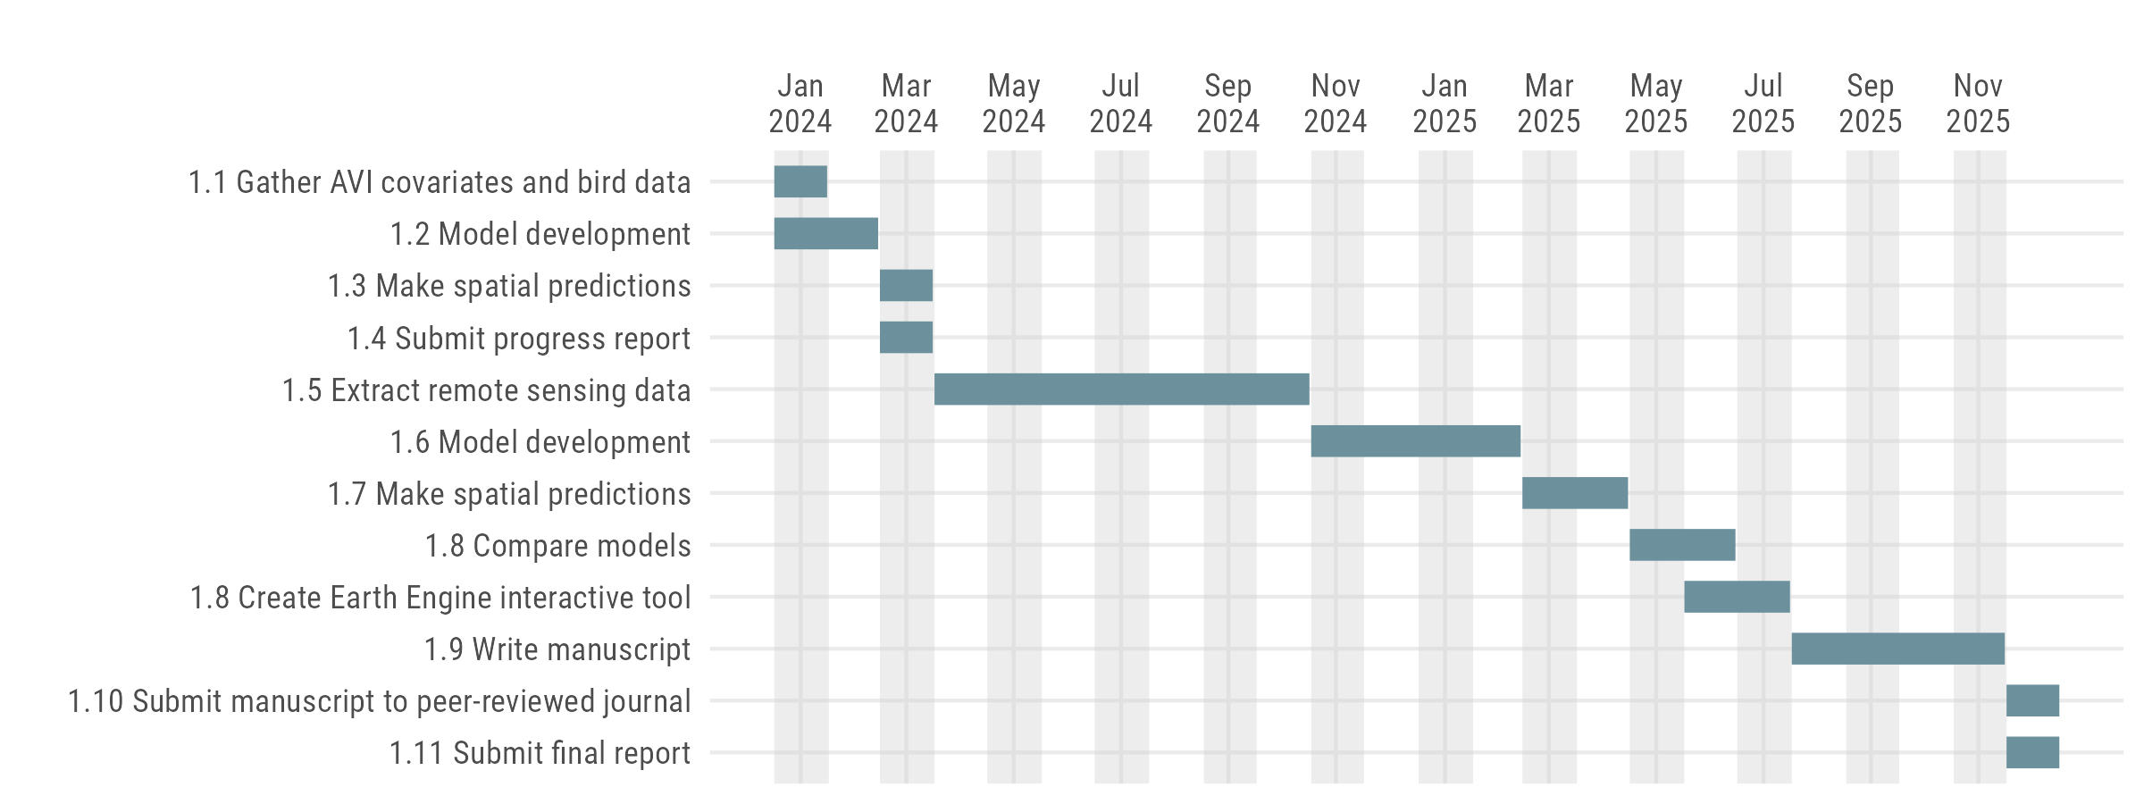

References

Brandt, J. P., M. D. Flannigan, D. G. Maynard, I. D. Thompson, and W. J. A. Volney. 2013. An introduction to Canada’s boreal zone: Ecosystem processes, health, sustainability, and environmental issues. Environmental Reviews 21:207–226.
Cumming, S. G., D. Stralberg, K. L. Lefevre, P. Sólymos, E. M. Bayne, S. Fang, T. Fontaine, D. Mazerolle, F. K. A. Schmiegelow, and S. J. Song. 2014. Climate and vegetation hierarchically structure patterns of songbird distribution in the Canadian boreal region. Ecography 37:137–151.
Demarchi, D. A. 1996. An introduction to the ecoregions of British Columbia. Wildlife Branch, Ministry of Environment, Lands; Parks Victoria, BC.
Felton, A., P.-O. Hedwall, R. Trubins, J. Lagerstedt, A. Felton, and M. Lindbladh. 2021. From mixtures to monocultures: Bird assemblage responses along a production forest conifer-broadleaf gradient. Forest Ecology and Management 494:119299.
Franklin, J. F., and K. N. Johnson. 2012. A Restoration Framework for Federal Forests in the Pacific Northwest. Journal of Forestry 110:429–439.
Hermosilla, T., M. A. Wulder, J. C. White, and N. C. Coops. 2022. Land cover classification in an era of big and open data: Optimizing localized implementation and training data selection to improve mapping outcomes. Remote Sensing of Environment 268:112780.
Hobson, K. A., and E. Bayne. 2000. Breeding Bird Communities in Boreal Forest of Western Canada: Consequences of “Unmixing” the Mixedwoods. The Condor 102:759–769.
Huberman, Y. L., and B. N. I. Eskelson. 2023. Conifer performance, stand productivity, and understory cover in varying densities of mixed conifer-broadleaf stands in southwestern British Columbia. Canadian Journal of Forest Research 53:430–443.
Natural Regions Committee. 2006. Natural regions and subregions of Alberta. Compiled by DJ Downing; WW Pettapiece. Government of Alberta, Edmonton, Alberta, Canada.
Venier, L. A., I. D. Thompson, R. Fleming, J. Malcolm, I. Aubin, J. A. Trofymow, D. Langor, R. Sturrock, C. Patry, R. O. Outerbridge, S. B. Holmes, S. Haeussler, L. D. Grandpré, H. Y. H. Chen, E. Bayne, L. De Grandpré, H. Y. H. Chen, E. Bayne, A. Arsenault, and J. P. Brandt. 2014. Effects of natural resource development on the terrestrial biodiversity of Canadian boreal forests. Environmental Reviews 22:457–490.

